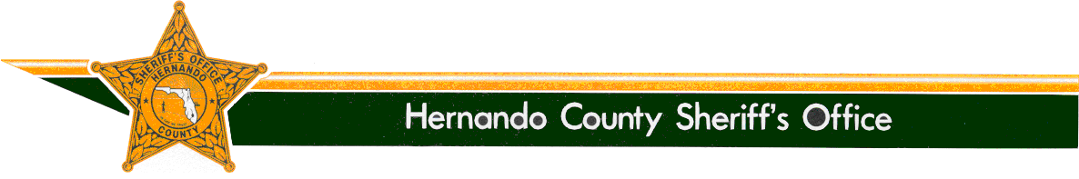

SHERIFF

Al Nienhuis
www.hernandosheriff.org

P.O. BOX 10070 – BROOKSVILLE, FL 34603-0070 FAX 352 796-0493 PHONE 352 754-6830

Media Release

From: Denise M. Moloney

Community/Media Relations Manager, 352-797-3609

Re: Detectives Bust Drug House near Pre-School

Date: September 16, 2016

On 09-16-16, detectives with the Hernando County Sheriff’s Office Vice and Narcotics Unit, along with members of the SWAT Team, executed a search warrant at 949 Cobblestone Drive in Spring Hill, the residence of Robert Pulitano.

The search warrant was the result of a lengthy investigation originating from a neighborhood complaint where undercover Vice and Narcotic detectives were able to purchase narcotics from Pulitano on several occasions. At approximately 9 a.m., detectives made contact with Pulitano and one other individual inside the residence who were taken into custody without incident.

Pursuant to the search, detectives located several baggies containing methamphetamine, a plastic bag containing marijuana, a container filled with methadone pills and several items of drug paraphernalia. Detectives also encountered unsafe living conditions and contacted Hernando County Code Enforcement who responded to evaluate the conditions. Code Enforcement representatives found numerous violations and will be following up with potential fines.

Pulitano’s residence, was within proximity of a church and a pre-school. Concern was expressed about the residence, as it was along a route utilized by parents who walk their children to and from the pre-school. Members of the church and pre-school, along with area residents, expressed their gratitude for the efforts of the Sheriff’s Office.

The individuals listed below were arrested on scene and charged as follows:

Robert Pulitano W/M 04-16-1954

- Sale of a controlled substance within 1000 feet of a church and daycare (2 counts)
- Sale of marijuana within 1000 feet of a church and daycare (3 counts)
- Possession of a structure for sale of narcotics (3 counts)
- Possession of Methamphetamine
- Possession of a controlled substance (4 counts)
- Possession with intent to sell a controlled substance
- Possession of Marijuana (4 counts)
- Possession of paraphernalia (4 counts)
- Total Bond $ 117,000

Michael Morford W/M 04-15-1954

- Possession of drug paraphernalia containing Methamphetamine residue
- Total Bond $ 1,000.

The Office of Sheriff:
The Office of the Sheriff is established by the Florida Constitution. As a constitutional officer, the Sheriff has the exclusive authority to administer his or her agency and is responsible for preserving the peace throughout the entire county, carrying out the laws of the state, the orders of Florida courts, and the ordinances of the Board of County Commissioners. The Sheriff is the chief law enforcement and correctional officer of the county.
Sheriff Al Nienhuis was initially appointed as the Sheriff of Hernando County by the Governor in January of 2011. He was then elected by the people of Hernando County in 2012, and remains accountable to them.

