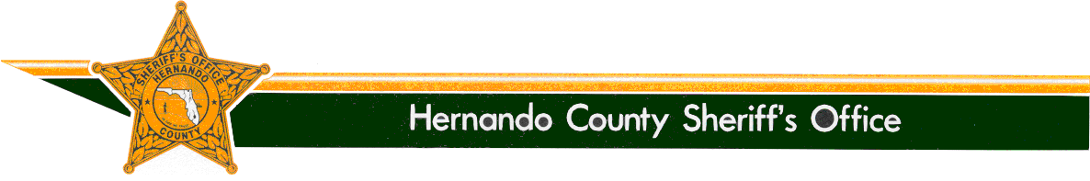

SHERIFF

Al Nienhuis
www.hernandosheriff.org

P.O. BOX 10070 – BROOKSVILLE, FL 34603-0070 FAX 352 796-0493 PHONE 352 754-6830

Media Release

From: Denise M. Moloney

Community/Media Relations Manager, 352-797-3609

Re: Update #2 – Suspect Takes Plea - Arrest Made - Spring Hill Man Sought for Dragging Dog Down Roadway

Date: June 5, 2019

Update #2

On today’s date, Gregory Tousignant accepted a plea deal of 270 days in the Hernando County Detention Center for the listed crime of Animal Neglect.

The last information received from the veterinarian caring for Ollie was that Ollie was well on his way to a full recovery and was thoroughly enjoying all of his visitors and gifts.

Update #1 – 05-09-19

On 05-08-19 just after 9 p.m., deputies conducting proactive patrols in the area of Commercial Way and the Outback Steakhouse observed a vehicle believed to be the one described in the BOLO (Be On the Look Out) for the animal cruelty incident (arrest warrant).

Deputy Vincent Spallino conducted a Traffic Stop on the green Ford F-150 at Frontage Road just off Commercial Way in front of the Microtel. The driver of the F-150 was identified as Gregory Tousignant.

Spallino requested Tousignant’s driver’s license. Tousignant told Spallino he had only an ID card, as his license was not valid.

Deputy Spallino placed Tousignant under arrest for the active warrant and for DWLSR (Driving While License Suspended/Revoked with Knowledge). His bond was set at $1,500.

At this time, there is no additional information available.

Original Information – 05-08-19

On 05-03-19 at 9:28 a.m., 911 dispatchers started to receive calls reporting a dog was being dragged behind a truck that was traveling down Northcliffe Boulevard in Spring Hill.

Witnesses indicated the dog was tied to the truck’s back bumper by a piece of rope that was attached to the dog’s collar.

The dog, a 1-year-old pit bull terrier mix, was able to free itself from the collar.

A witness at the scene tended to the injured dog and proceeded to take the dog for additional treatment. The dog is expected to make a full recovery.

While a suspect wasn’t immediately identified, through investigation, deputies were finally able to identify the dog’s owner as Gregory Tousignant W/M DOB/07-02-1960.

Witnesses said it appears Tousignant was unaware the dog had jumped out of the bed of his truck. It is illegal to carry any pet in the bed of truck that is not properly secured and prevented from jumping out of the moving vehicle.

On 05-08-19, County Judge Kristie Ruppe issued a warrant for Tousignant’s arrest on a misdemeanor charge of Cruelty to Animals, which carries a $1,000 bond.

As Tousignant is a transient, anyone with information regarding his whereabouts is asked to contact the Sheriff’s Office at 352-754-6830.

The Office of Sheriff:
The Office of the Sheriff is established by the Florida Constitution. As a constitutional officer, the Sheriff has the exclusive authority to administer his or her agency and is responsible for preserving the peace throughout the entire county, carrying out the laws of the state, the orders of Florida courts, and the ordinances of the Board of County Commissioners. The Sheriff is the chief law enforcement and correctional officer of the county.
Sheriff Al Nienhuis was initially appointed as the Sheriff of Hernando County by the Governor in January of 2011. He was then elected by the people of Hernando County in 2012, and remains accountable to them.

