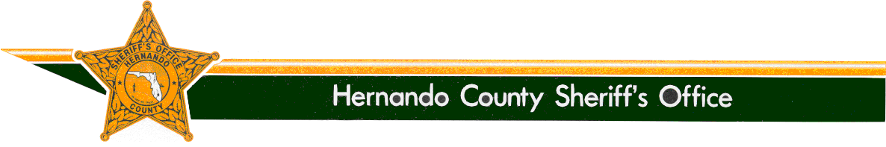

SHERIFF

Al Nienhuis
www.hernandosheriff.org

P.O. BOX 10070 – BROOKSVILLE, FL 34603-0070 FAX 352 796-0493 PHONE 352 754-6830

Media Release

From: Denise M. Moloney

Community/Media Relations Manager, 352-797-3609

Re: Teen Driver Challenge – December-2018

Date: December 16, 2018

The Hernando County Sheriff’s Office Teen Driver Challenge is a defensive driving and vehicle control program designed for licensed teenage drivers. The two-day program is designed to provide young drivers, age 16, 17 and 18, with the knowledge and understanding of vehicle dynamics and human kinetics, the forces created by an automobile and the effects of the forces on the human body.

The next Teen Driver Challenge Session is being held on 12-14-18 and 12-15-18. The Friday night classroom instruction is held from 5 p.m. to 9 p.m. at the Hernando County Detention Center (please go to the main door), located at 16425 Spring Hill Dr., Brooksville. On Saturday, the range instruction is held from 8 a.m. to 5 p.m. at the Brooksville-Tampa Bay Regional Airport located at 2495 Broad Street, Brooksville. Each student attending will receive instructions on where to meet for the range.

Only 10 students are allowed per session. If you are interested in this FREE program and are a Hernando County student/resident with a valid driver’s license, please call for more information at 352-797-3660.

A printable registration form is also available on our website at www.hernandosheriff.org.

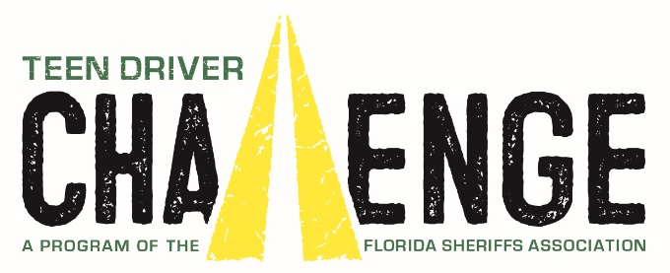

The Office of Sheriff:
The Office of the Sheriff is established by the Florida Constitution. As a constitutional officer, the Sheriff has the exclusive authority to administer his or her agency and is responsible for preserving the peace throughout the entire county, carrying out the laws of the state, the orders of Florida courts, and the ordinances of the Board of County Commissioners. The Sheriff is the chief law enforcement and correctional officer of the county.
Sheriff Al Nienhuis was initially appointed as the Sheriff of Hernando County by the Governor in January of 2011. He was then elected by the people of Hernando County in 2012, and remains accountable to them.

