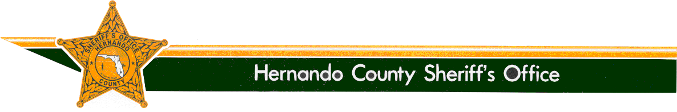

SHERIFF

Al Nienhuis
www.hernandosheriff.org

P.O. BOX 10070 – BROOKSVILLE, FL 34603-0070 FAX 352 796-0493 PHONE 352 754-6830

MEDIA RELEASE

From: Denise Moloney
Public Relations Manager, 352-797-3609

Re: Missing Endangered Adult – Joan Kaloustian – 2022-21400 – SILVER ALERT

Date: July 19, 2022

SILVER ALERT

The Hernando County Sheriff’s Office is requesting assistance from our media partners and the community in locating a MISSING ENDANGERED ADULT.

Joan Kaloustian was last seen on 07-17-22 at approximately 4 p.m., at her residence in the Highpoint subdivision (Brooksville). At that time she was visiting with family members. Mrs. Kaloustian remained at her residence when family members left to travel home.

At some point between that time and this evening, Mrs. Kaloustian left her residence in her white Dodge Caravan, bearing Florida handicapped tag/JX37U (photo attached). Mrs. Kaloustian does not have a cell phone with her.

Mrs. Kaloustian is diagnosed with dementia.

Joan Kaloustian’s physical description is as follows:
White Female
Date of Birth – 04-25-1946
Height – 5’7”
Weight – 145
Hair – Grey
Eyes – Brown
Last seen wearing – Unknown.

If you have seen Joan Kaloustian, or know her current whereabouts, please call 9-1-1 or the Hernando County Sheriff’s Office at 352-754-6830. If outside Hernando County, please contact your local law enforcement agency.

Thank you.
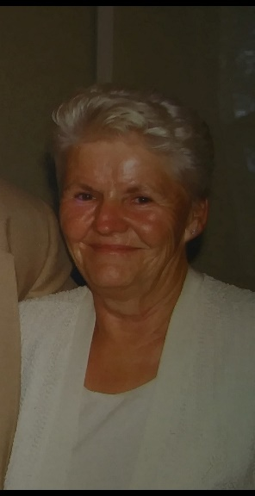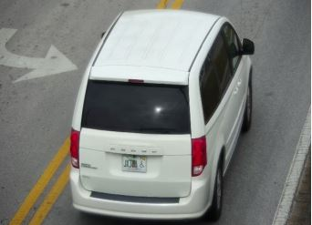
Joan Kaloustian and Actual Vehicle

The Office of Sheriff:

The Office of the Sheriff is established by the Florida Constitution. As a constitutional officer, the Sheriff has the exclusive authority to administer his or her agency and is responsible for preserving the peace throughout the entire county, carrying out the laws of the state, the orders of Florida courts, and the ordinances of the Board of County Commissioners. The Sheriff is the chief law enforcement and correctional officer of the county.

Sheriff Al Nienhuis was initially appointed as the Sheriff of Hernando County by the Governor in January of 2011. He was then elected by the people of Hernando County in 2012, ran unopposed in 2016, and was re-elected in 2020. Sheriff Nienhuis remains accountable to the people of Hernando County.

